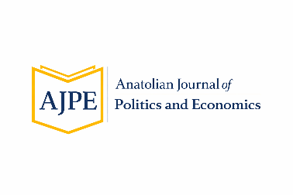
Volume: 1 Issue:1 Year: 2026 Pages:
Peer Reviewed Journal
Submitted: ………………… | Accepted: ………………….
ANATOLIAN JOURNAL OF POLITICS AND ECONOMICS
RESEARCH ARTICLE
Title (English)*
Name SURNAME, Name SURNAME, Name SURNAME
ABSTRACT
This draft format includes the writing and formatting guidelines for manuscripts to be submitted to the Anatolian Journal of Politics and Economics (AJPE). Authors are required to prepare their manuscripts using this template. Creating a new Word document and transferring the text into that file is not considered appropriate. Manuscripts should be edited directly within this template. In particular, no modifications should be made to the formatting features (such as font type, font size, alignment, margins, etc.) of the Turkish and English cover sections located on the first two pages.
In the abstract section, the original contributions of the study should be clearly emphasized, and the main findings should be presented in a concise manner.
The abstract should be written in a single column, justified alignment, and as a single paragraph. Font and formatting settings should follow the Styles available in the Home tab of Microsoft Word; the text should be written in 10-point font with 1.15 line spacing, and the paragraph spacing before and after should be set to 0 pt. The abstract should be 150–200 words in length. It should not contain uncommon abbreviations, direct quotations, citations, equations, or expressions with subscripts and superscripts.
Following the abstract, 3 to 5 keywords and 2 to 3 JEL codes that describe the content of the study should be provided.
Keywords: Keyword1, Keyword2, Keyword3
JEL Codes: JEL1, JEL2

1. Article Preparation and Writing Guidelines
Authors are required to use the template provided by the journal when preparing their manuscripts. Authors should not create a new Word document and subsequently transfer the manuscript into this template. Manuscripts must be prepared directly within the existing template. In particular, no changes should be made to the formatting specifications of the Turkish and English cover pages on the first two pages, including font type, font size, alignment, margins, and other formatting settings.
All manuscripts submitted to the journal must fully comply with the principles specified in these author guidelines. Manuscripts that do not conform to the prescribed requirements will be returned to the authors without being sent for peer review. Where deemed necessary, editorial and language-related corrections may be made to submitted manuscripts by the Editor or Assistant Editors.
The minimum word-count requirements are as follows: manuscripts based exclusively on quantitative research must contain at least 4,500 words, while manuscripts in other fields must contain at least 5,500 words. The total length of the manuscript, including the Abstract and References sections, must not exceed 28 pages.
For manuscripts written in English, only an English “Abstract” is required; a Turkish “Öz” is not necessary. The abstract must be between 150 and 200 words and must include at least three keywords and at least two JEL classification codes.
For manuscripts written in Turkish, spelling, punctuation, and abbreviations must conform to the current Yazım Kılavuzu (Spelling Guide) of the Turkish Language Association (Türk Dil Kurumu—TDK). All manuscripts must be prepared using Microsoft Word 2010 or a later version.
1.1. Article Page Layout
For manuscripts prepared using this template, no changes should be made to the page layout settings, including page size, margins, headers, and footers. These settings have been predefined in accordance with the journal’s standard formatting requirements and must be retained without modification.
Furthermore, all textual elements throughout the manuscript—including headings, body text, footnotes, table titles, figure captions, chart titles, and table contents—must be formatted exclusively using the styles defined under the “Styles” (Quick Styles) section of the template. Authors must not use different fonts, font sizes, or alignment settings; only the styles predefined in the template should be applied throughout the manuscript.
Compliance with these requirements is mandatory to maintain the journal’s formatting consistency and to ensure an orderly and efficient publication process.
1.1.2. Article Headings
Headings in the manuscript must be created automatically using the “1.Düzey_başlık” (Level 1 Heading), “2.Düzey_başlık” (Level 2 Heading), and “3.Düzey_başlık” (Level 3 Heading) styles defined in the “Styles” section of Microsoft Word.
The formatting specifications for headings are as follows: first-level headings must be 14 pt, second-level headings 13 pt, and third-level headings 12 pt. All headings must be bold. Third-level headings must also be italicized.
All headings must have a first-line indent of 0.8 cm, with 12 pt spacing before and 6 pt spacing after the heading. Line spacing must be set to single. Headings must be written in title case, with the initial letter of each principal word capitalized and the remaining letters in lowercase (e.g., Evaluation of Research Findings).
Headings must be numbered hierarchically and systematically, as illustrated below:
1. Heading A (First Level)
1.1. Heading B (Second Level)
1.1.1. Heading C (Third Level)
The use of fourth-level headings is not recommended. However, where a fourth-level heading is unavoidable, it should be italicized without bold formatting and otherwise follow the formatting specifications applicable to third-level headings.
2. Main Text
The main body of the manuscript must be formatted using the “Ana Metin” (Main Text) style available in the Quick Styles section of Microsoft Word. The body text must be justified, and the first line of each paragraph must have an indent of 0.8 cm.
The main text must use Garamond, 12 pt, regular font. Line spacing must be set to 1.2 lines, with 6 pt spacing before and after each paragraph. Compliance with these formatting requirements is mandatory to maintain visual consistency throughout the manuscript and ensure conformity with academic writing standards.
2.1. Tables, Charts, and Figures
Tables, figures, and charts included in the manuscript must be placed in the appropriate sections of the text. Each must be numbered consecutively as Table 1, Figure 1, and Chart 1, respectively, and explicitly referred to within the text.
For example: “An example of a table is presented in Table 1, an example of a chart in Chart 1, and an example of a figure in Figure 1.”
Table titles must appear above the relevant table. In contrast, chart and figure captions must appear below the corresponding visual. All table titles, chart titles, and figure captions must be formatted using the “TGŞ_başlık” style defined in the Quick Styles section of the template.
The contents of tables must be formatted using the “Tablo_içerik” (Table Content) style available in the Quick Styles section. Table header rows must be bold, while all other data rows must use regular font. All text appearing in tables, charts, and figures must use Poppins, 9 pt.
Care must also be taken to ensure that tables and figures do not extend beyond the page margins. Where necessary, a font size smaller than 9 pt may be used to fit the content within the page boundaries. The use of landscape page orientation should be avoided wherever possible.
Source information for tables, figures, and charts must be provided immediately below the relevant visual, as illustrated in the examples. The “TGŞ_kaynak” style defined in the template must be used for formatting source information.
Tablo 1: Initial Letters Should Be Capitalized
1. Column | 2. Column | 3. Column | 4. Column | 5. Column | 6. Column | 7. Column | 8. Column
X | X | X | X | X | A | X | A
Y | Y | Y | Y | Y | B | Y | B
Z | Z | Z | Z | Z | C | Z | C
Source: OECD
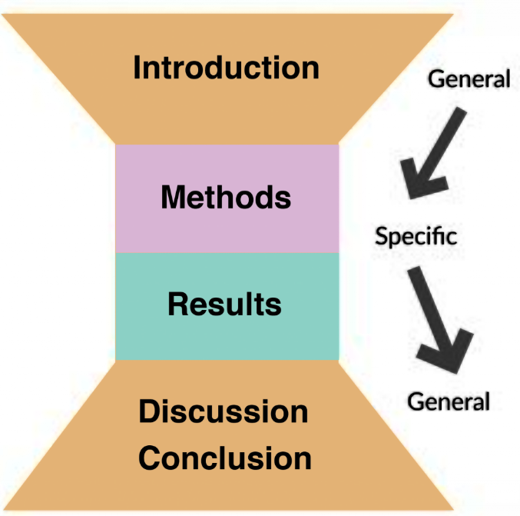
Figure 1: Initial Letters Should Be Capitalized
2.2. Quotations
Direct quotations included in the manuscript must be formatted according to their length. In this template, quotations must be formatted using the “Alıntı” (Quotation) style defined in the Quick Styles section of Microsoft Word. The applicable requirements are explained below.
Short Quotations (Fewer than 40 Words)
- Short quotations must appear within the main text in italics and enclosed in double quotation marks (“…”).
- The formatting must be consistent with the main text: justified alignment, Garamond 12 pt, and 1.2 line spacing.
- The source must be cited in parentheses together with the relevant page number.
Örnek:
According to Smith, “the development of modern economic systems is closely associated with individuals’ rational patterns of behavior and social institutions” (Smith, 2008: 74).
Long Quotations (40 Words or More)
- Long quotations must be presented as a separate paragraph from the main text.
- Double quotation marks must not be used for such quotations.
- The text must be justified and indented 1 cm from the left margin, using Garamond 11 pt and single line spacing.
- The source information must be provided in parentheses at the end of the quotation, followed by a period.
- The “Alıntı” (Quotation) style defined in the template must be used for such quotations.
Örnek:
Processes of social transformation cannot be explained solely through economic indicators. Changes in institutional structures, cultural values, and political preferences collectively demonstrate that social development is a multidimensional process. Therefore, evaluating the economic and political conditions of a particular period together allows for more robust historical analyses (Yılmaz, 2015: 118).
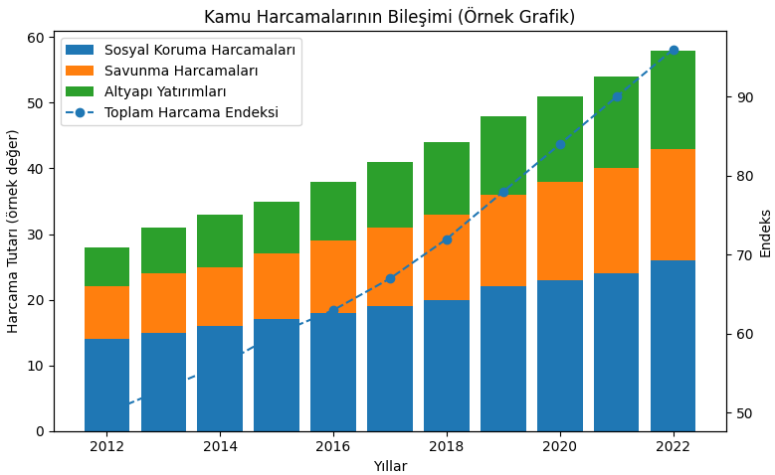
Source:: (OECD, 2024)
Chart 1: Initial Letters Should Be Capitalized
2.3. Presentation of Mathematical Equations
If the study is applied research in the field of social sciences and includes statistical analyses, econometric models, or mathematical expressions, the following requirements must be observed:
- Equations must be created using the “Insert > Equation” function in Microsoft Word.
- Equations must be positioned within the text using justified alignment. Equation numbers must be shown in parentheses as (1), (2), (3), etc., and positioned on the left margin.
- Before each equation, the manuscript must clearly explain what the model or mathematical expression represents and the purpose for which it is used.
3. Page Numbers
Page numbers must not appear anywhere in the manuscript. In addition, headers, footers, running heads, or similar elements must not be used.
No text, title, author name, date, or other information should be added to the header or footer areas. Page numbering and all header/footer arrangements will be completed by the journal during the publication process. Authors must therefore refrain from making any changes or additions to these areas.

4. References and Citations
All in-text citations must conform to the rules of the APA 7th Edition. The reference list at the end of the manuscript must be arranged alphabetically by the surname of the first author. Where appropriate, multiple sources may be cited simultaneously within the text.
Examples of in-text citation formats are provided below.
4.1. In-Text Citation Methods
Two different methods may be used when citing sources within the text:
- Parenthetical Citation
Significant changes occurred in international security policies following the end of the Cold War. Since the 1990s, many countries have increasingly resorted to military intervention as an instrument of foreign policy (Brown, 2009: 27).
- Narrative Citation
According to Kaya (2016: 88), one of the primary objectives of educational reforms is to accelerate the process of social transformation and restructure the education system so that it can adapt to emerging needs.
4. 2. Citations to Works by Two Authors
When citing a work written by two authors, the surnames of both authors must be provided.
- (Kara and Demir, 2018: 45)
- According to Kara and Demir (2018: 45),
4.3. Citations to Works by Three or More Authors
When citing a source with three or more authors, the surname of the first author must be followed by “et al.”
- (Aydın et al., 2005: 25)
- According to Aydın et al. (2005: 25), ...
4.4. Citations to Corporate or Institutional Authors
When citing a work authored by an institution or organization, the name of the relevant institution or organization must be used. Where appropriate, the institutional name may be abbreviated. At first mention, both the full name and abbreviation must be provided. Subsequent citations may use only the abbreviation.
However, if the institutional name is short or its abbreviation is not widely recognized, the full institutional name should be used consistently.
First parenthetical citation:
- (Türkiye İstatistik Kurumu [TÜİK], 2020)
Subsequent citations:
- (TÜİK, 2020)
First narrative citation:
- Türkiye İstatistik Kurumu (TÜİK, 2020)
Subsequent narrative citations:
- TÜİK (2020)
4.5. Citing Multiple Sources Within the Same Parentheses
When multiple sources are cited within the same parentheses, they must be listed alphabetically according to the surname of the first author and separated by semicolons (;).
Example:
- (Demirtaş and Yıldız, 2017; Kaya, 2009; Özkan, 2015)
For more detailed information on APA Style, authors may consult the official APA Style website: https://apastyle.apa.org/
5. Reference List Formatting
The References section at the end of the manuscript must be presented without section numbering. All sources listed in this section must be formatted in accordance with the APA 7th Edition.
The “Kaynakça” (References) style defined in the Quick Styles section of Microsoft Word must be used to format the reference list. The principal formatting specifications are as follows:
- Alignment: The text must be justified.
- Indentation: Each reference entry must use a hanging indent of 1.25 cm.
- Font: Garamond, 11 pt, regular.
- Line spacing: Single.
- Paragraph spacing: 6 pt must be left before and after each reference entry.
The reference list must be arranged alphabetically according to the authors’ surnames. Compliance with these requirements is necessary both to maintain the visual consistency of the manuscript and to ensure conformity with academic writing standards. Authors are expected to format the References section exclusively using the style defined in the journal template.

Declarations
1. Ethics Committee Approval
Ethics committee approval was not required for this study.
2. Research and Publication Ethics Statement
This study was prepared in accordance with the principles of scientific research and publication ethics.
3. Author Contributions
The authors contributed equally to this study and jointly participated in the research design, data collection and analysis, interpretation of the findings, writing of the manuscript, and approval of the final version.
4. Conflict of Interest Statement
The authors declare that there is no conflict of interest regarding this study.

References (The DOI numbers of all references that have a DOI must also be included in the reference list.)
Aydın, H. (2012). Ekonomik büyümenin belirleyicileri üzerine kuramsal yaklaşımlar. İstanbul: Akademi Yayınları.
Brown, P., & Taylor, R. (2015). Financial markets and long-term economic growth. International Journal of Economic Studies, 12(3), 145–168.
Demir, T., & Yıldız, A. (2016). Finansal sistem gelişimi ve ekonomik büyüme ilişkisi: Gelişmekte olan ülkeler üzerine bir değerlendirme. Uluslararası Ekonomi Araştırmaları Dergisi, 4(2), 145–162.
Garcia, M., & Lopez, J. (2017). Banking sector competition and economic performance in emerging economies. Journal of Financial Development, 9(1), 33–52.
Kara, B., & Demirtaş, F. (2011). Finansal gelişme ile ekonomik büyüme arasındaki ilişki: Türkiye örneği. Anadolu İktisat Araştırmaları Dergisi, 3(2), 59–74.
Kaya, O., & Özdemir, H. (2018). Finansal piyasaların derinliği ve büyüme dinamikleri. İktisat Politikası Araştırmaları Dergisi, 5(1), 33–49.
Smith, J. (2013). Economic development and financial institutions. London: Routledge.
Sarı, M., & Çelik, E. (2017). Finansal gelişmişlik göstergeleri ve makroekonomik performans. Maliye ve Ekonomi Araştırmaları, 9(2), 117–134.
Wilson, D., & Clark, A. (2019). Financial deepening and macroeconomic stability. Global Economic Review, 48(2), 201–220.
Yılmaz, K., & Arslan, D. (2015). Finansal sistem derinliği ve büyüme ilişkisi: Panel veri analizi. Ekonomik Yaklaşımlar Dergisi, 26(96), 45–63.

* If the study requires ethics committee approval and this information is not stated within the manuscript, an explanation regarding the relevant ethics committee approval should be provided in this footnote section. Title, Institution/University, Sub-unit (Faculty, Institute, Vocational School, etc.), City/Country, ORCID: 0000-0001-0002-0003, e-mail: aaaa.bbb@ ddd.edu.tr (Corresponding Author) [This note should be added at the end of the line for the corresponding author.]
Title, Institution/University, Sub-unit (Faculty, Institute, Vocational School, etc.), City/Country, ORCID: 0000-0001-0002-0003, e-mail: aaaa.bbb@ ddd.edu.tr
Title, Institution/University, Sub-unit (Faculty, Institute, Vocational School, etc.), City/Country, ORCID: 0000-0001-0002-0003, e-mail: aaaa.bbb@ ddd.edu.tr

